# Compute

1. **A user has configured a website and launched it using the Apache web server on port 80. The user is using ELB with the EC2 instances for Load Balancing. What should the user do to ensure that the EC2 instances accept requests only from ELB?**

Configure the security group of EC2, which allows access to the ELB source security group

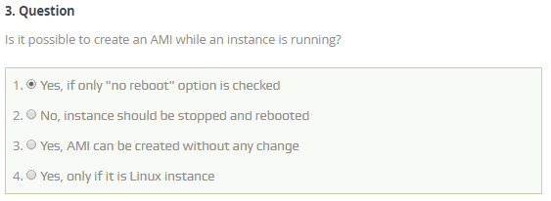

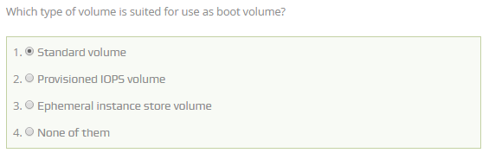

Ans: A (Standard Volume is Magnetic Storage)

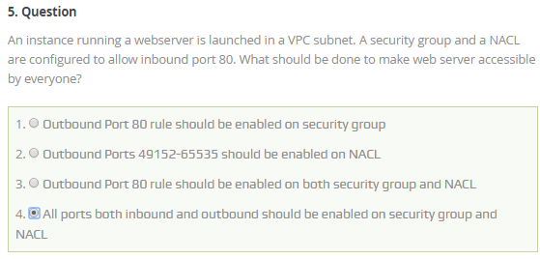

Ans: B

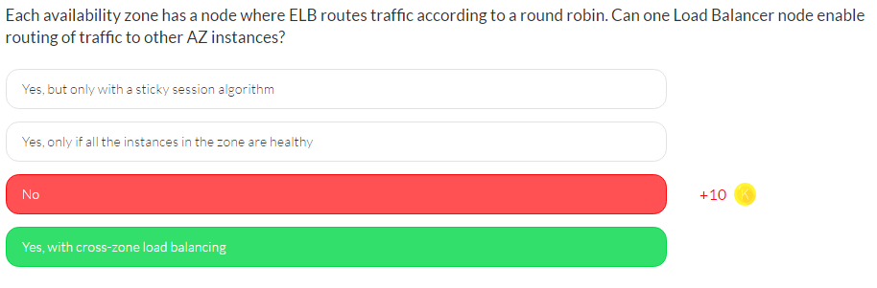

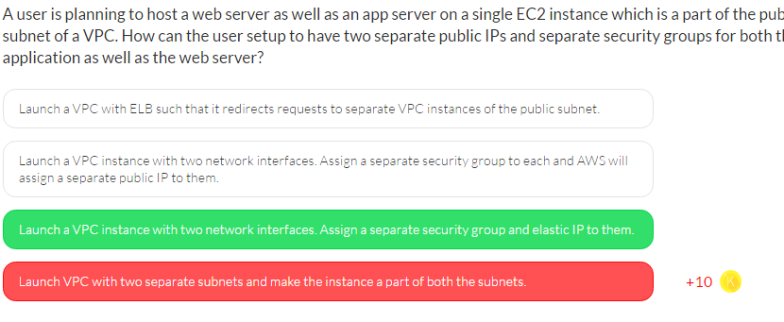

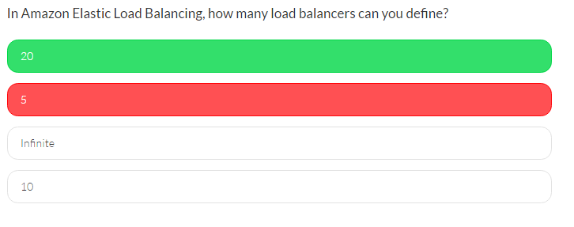

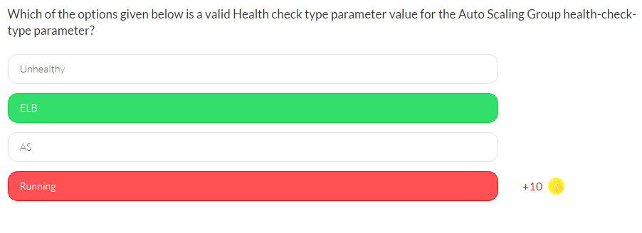

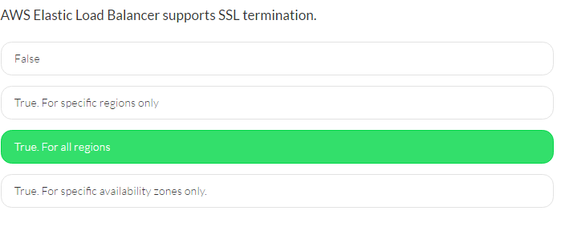

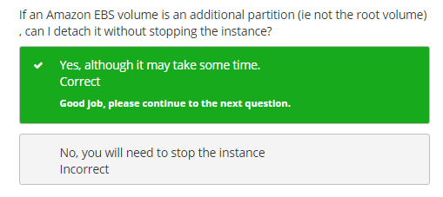

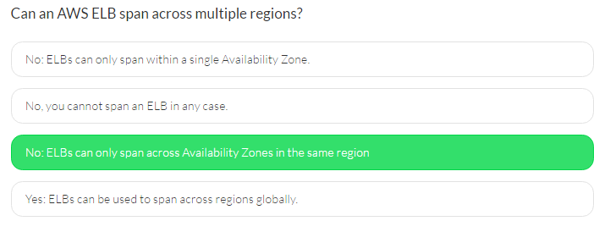

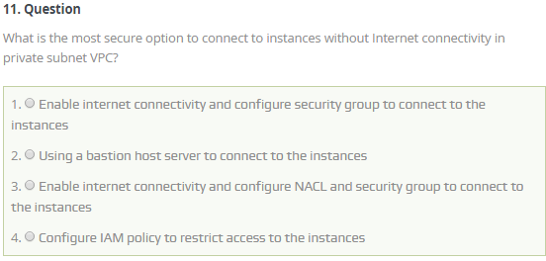

Ans: B

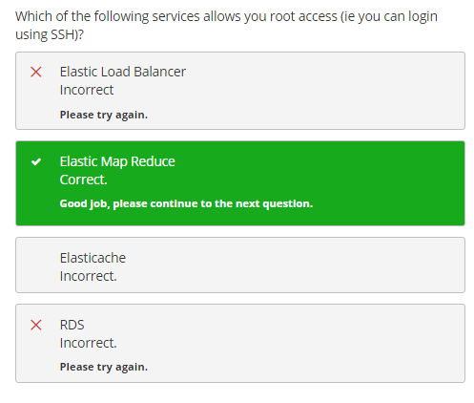

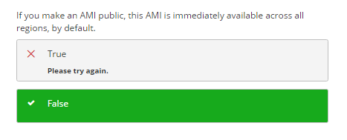

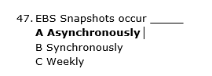

# Storage

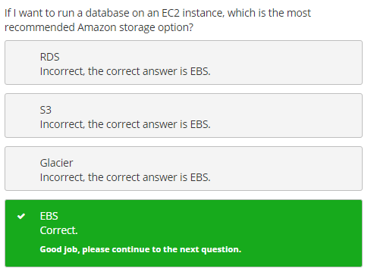

1. **A friend wants you to set up a small BitTorrent storage area for him on Amazon S3. You tell him it is highly unlikely that AWS would allow such a thing in their infrastructure. However you decide to investigate. Which of the following statements best describes using BitTorrent with Amazon S3?**

You can use the BitTorrent protocol but only for objects that are less than 5 GB in size.

Amazon S3 does not support the BitTorrent protocol because it is used for pirated software.

1. **You are planning and configuring some EBS volumes for an application. In order to get the most performance out of your EBS volumes, you should attach them to an instance with enough ________ to support your volumes.**

Bandwidth

1. **Your EBS volumes do not seem to be performing as expected and your team leader has requested you look into improving their performance. Which of the following is not a true statement relating to the performance of your EBS volumes?**

Frequent snapshots provide a higher level of data durability and they will not degrade the performance of your application while the snapshot is in progress.

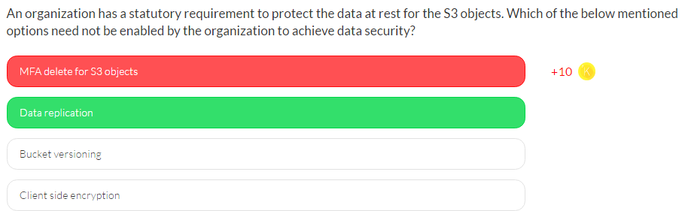

AWS S3 provides multiple options to achieve the protection of data at REST. The options include

1. **Permission**(Policy),
2. **Encryption** (Client and Server Side),
3. **Bucket Versioning** and
4. **MFA** **based delete**.

The user can enable any of these options to achieve data protection.

Data replication is an internal facility by AWS where S3 replicates each object across all the Availability Zones and the organization need not enable it in this case.

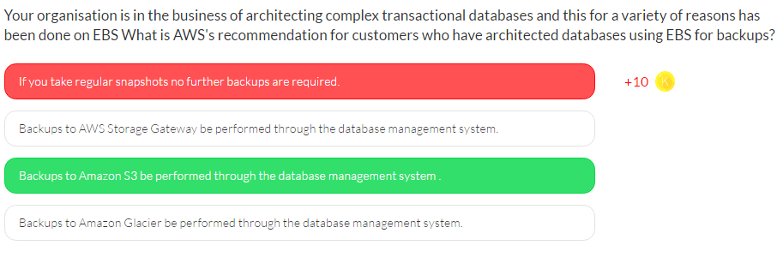

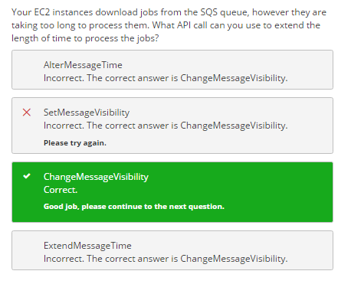

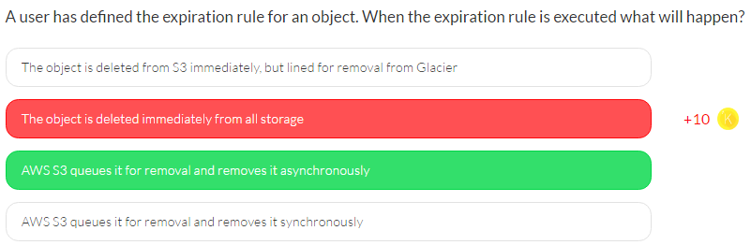

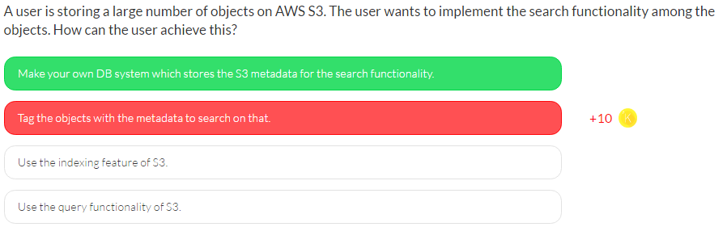

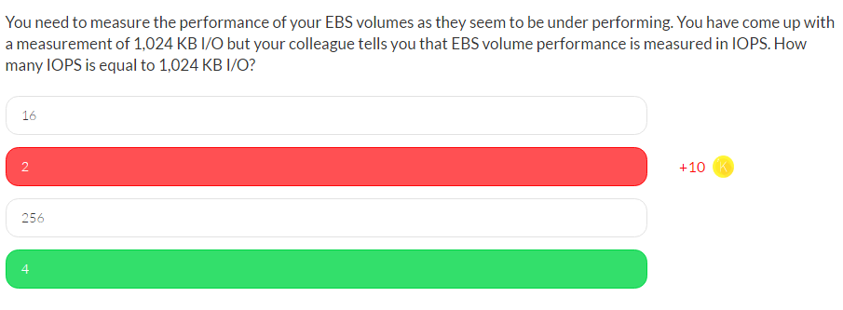

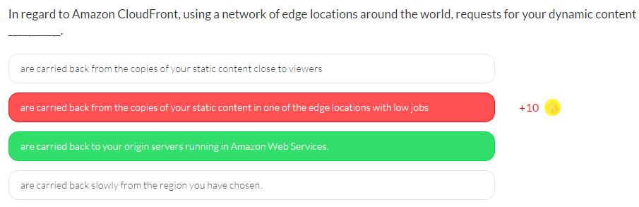

# IAM

1. **After a major security breach your manager has requested a report of all users and their credentials in AWS. You discover that in IAM you can generate and download a credential report that lists all users in your account and the status of their various credentials, including passwords, access keys, MFA devices, and signing certificates. Which following statement is incorrect in regards to the use of credential reports?**

Credential reports are downloaded XML files.

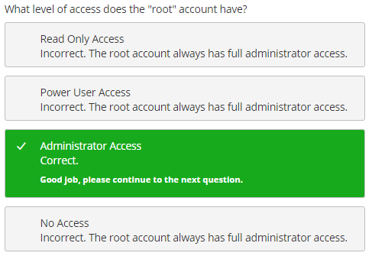

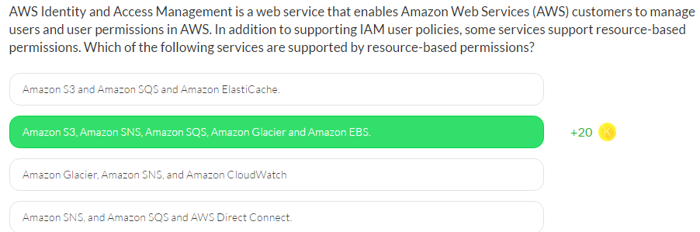

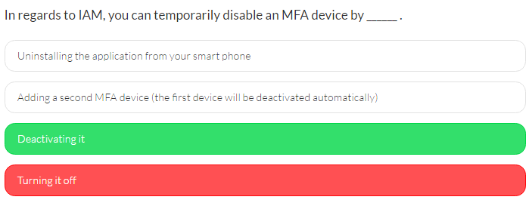

# DB

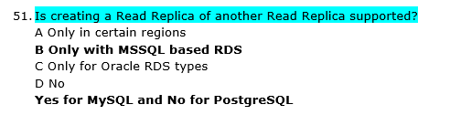

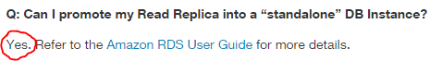

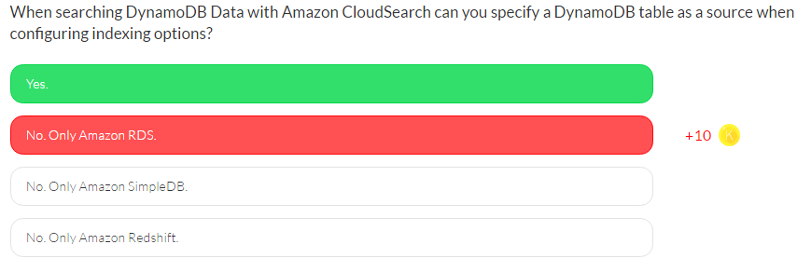

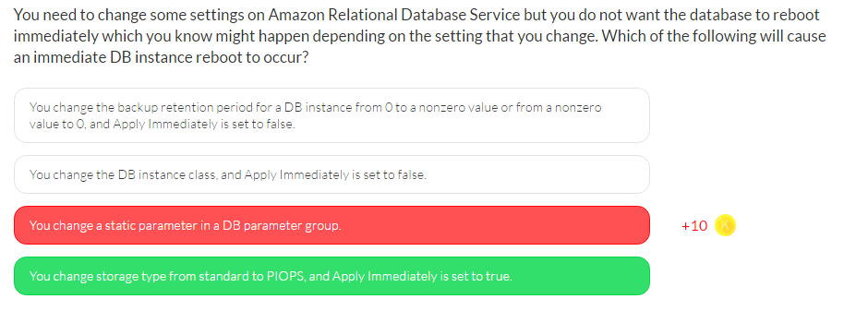

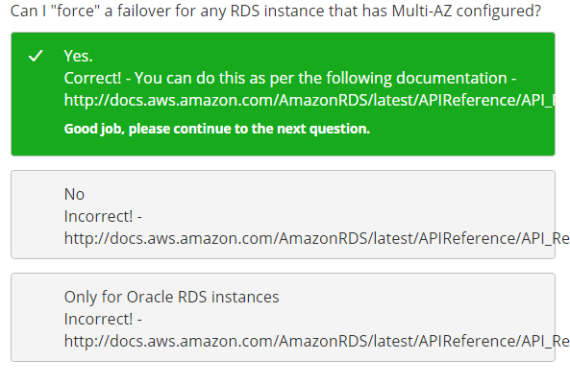

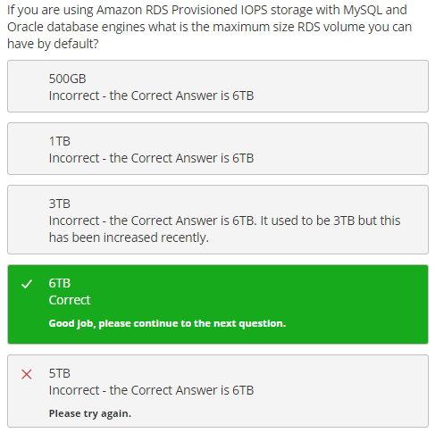

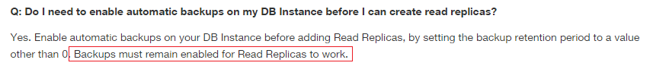

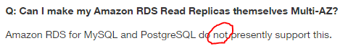

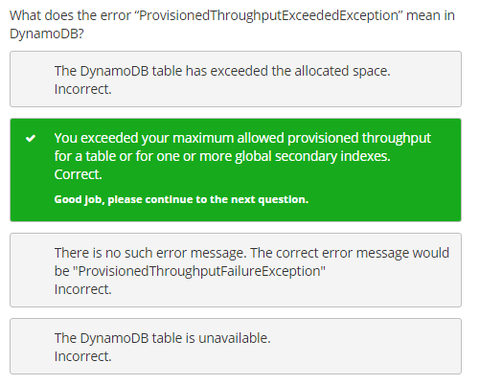

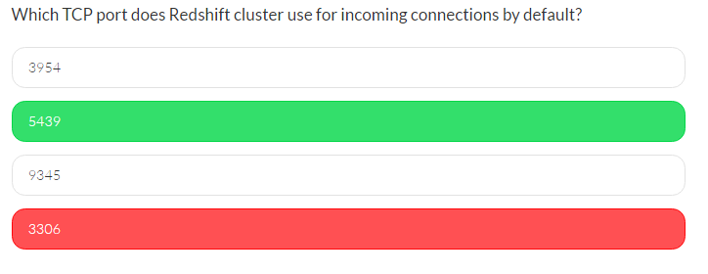

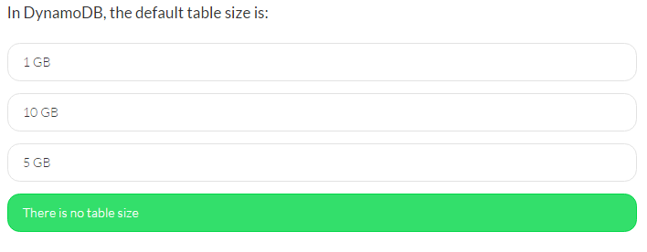

# VPC

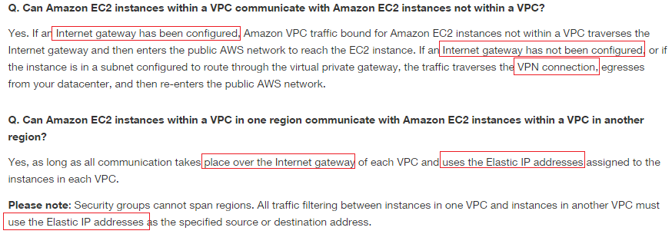

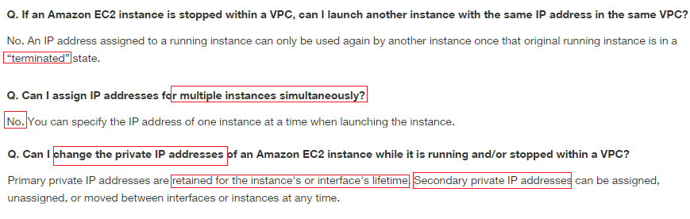

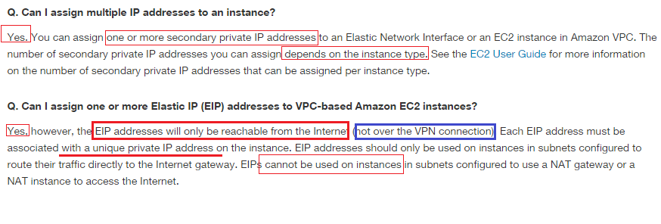

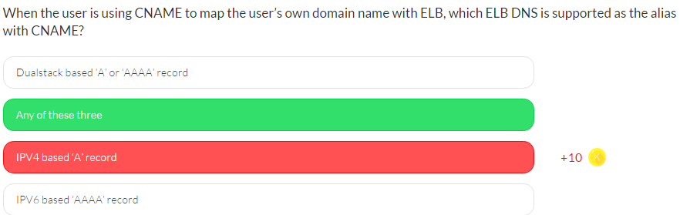

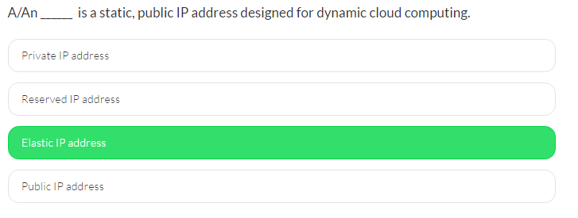

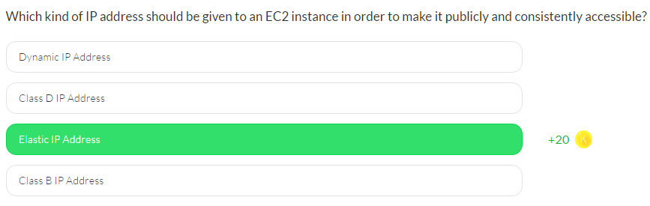

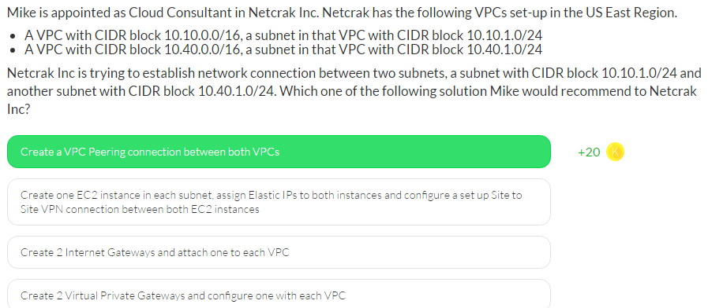

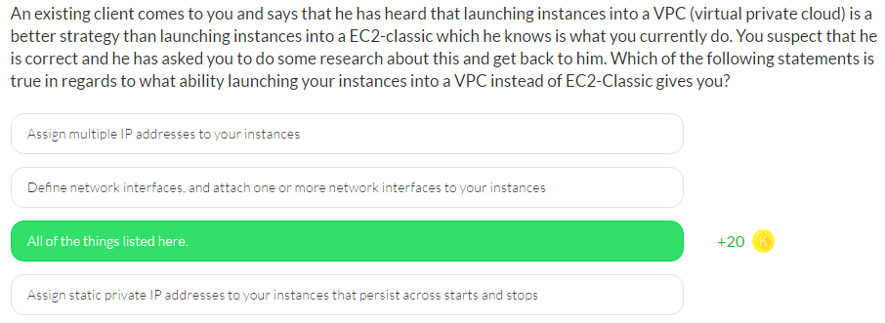

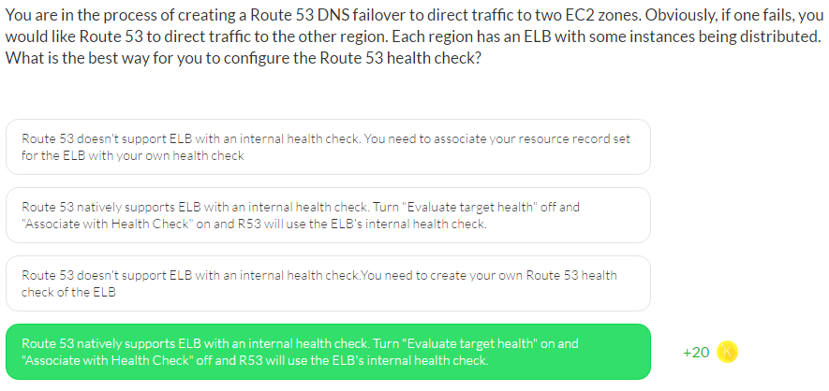

# SQS:

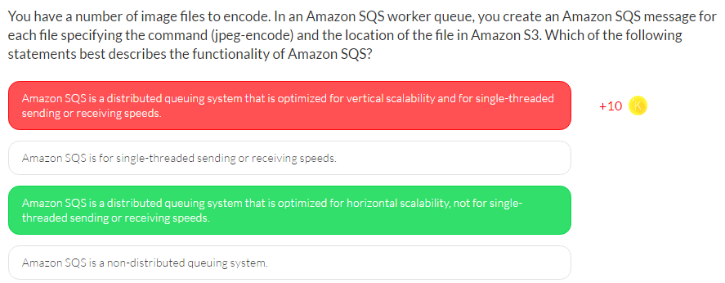

# SES

